INTERNSHIP TRAINING ON LEARN BENCH INDIA AT

INTERSHIP REPORT SUBMITTED BY
DEPARMENT OF COMPUTER SCIENCE

GAYATHRI S 222506867
KAVYA BHARATHI 222506872

UNDER THE GUIDANCE OF
MS.PRIYANKA

DEPARTMET OF COMPUTER SCIENCE


DR. MGR JANAKI COLLEGE OF ARTS AND SCIENCE FOR WOMEN
CHENNAI – 28
2026 – 2027
ACKNOWLEDGEMENT
We express our sincere gratitude to our esteemed Correspondent Kalaimamani Dr. LathaRajendran and Chairman Dr. Kumar Rajendran for their constant support.
Our special thanks to our principal Dr. R. Manimekalai, Vice Principal Dr. Lakshmi Balaji, Dean of Academics Dr. K. Latika, and Dean of Students Dr. V.C. Shanti Lakshmi for their encouragement and support.
We would like to thank our guide MS. PRIYANKA and Dr.K.Ganga Devi, Head of the Department of Computer Science for her valuable supervision. Further, we wish to thank our department members for their sincere and valuable guidance.

Company Profile
Learn Bench India Pvt. Ltd. is an IT training and software development company located in Vadapalani, Chennai. The company offers training in Python, Java, Artificial Intelligence, Machine Learning, Data Science, Web Development, Cloud Computing, and Full Stack Development. It focuses on practical learning through project and industry-oriented training, enabling students to acquire technical and professional skills required for software development careers.
Objectives of the Internship
- Learn Python programming fundamentals.
- Understand programming logic and problem-solving.
- Develop real-world applications using Python.
- Gain knowledge of object-oriented programming.
- Learn file handling and database connectivity.
- Improve debugging and testing skills.
- Build confidence in software development.

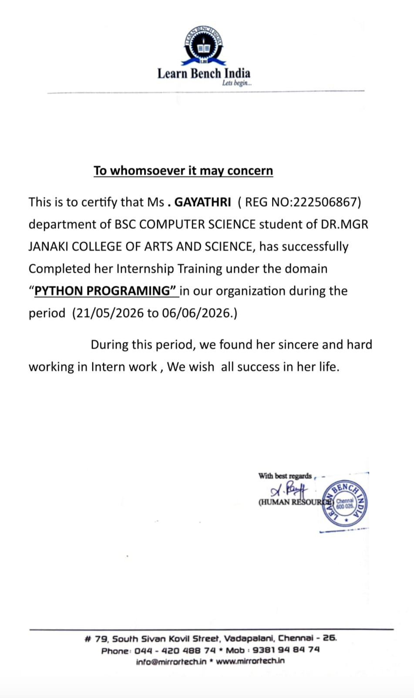
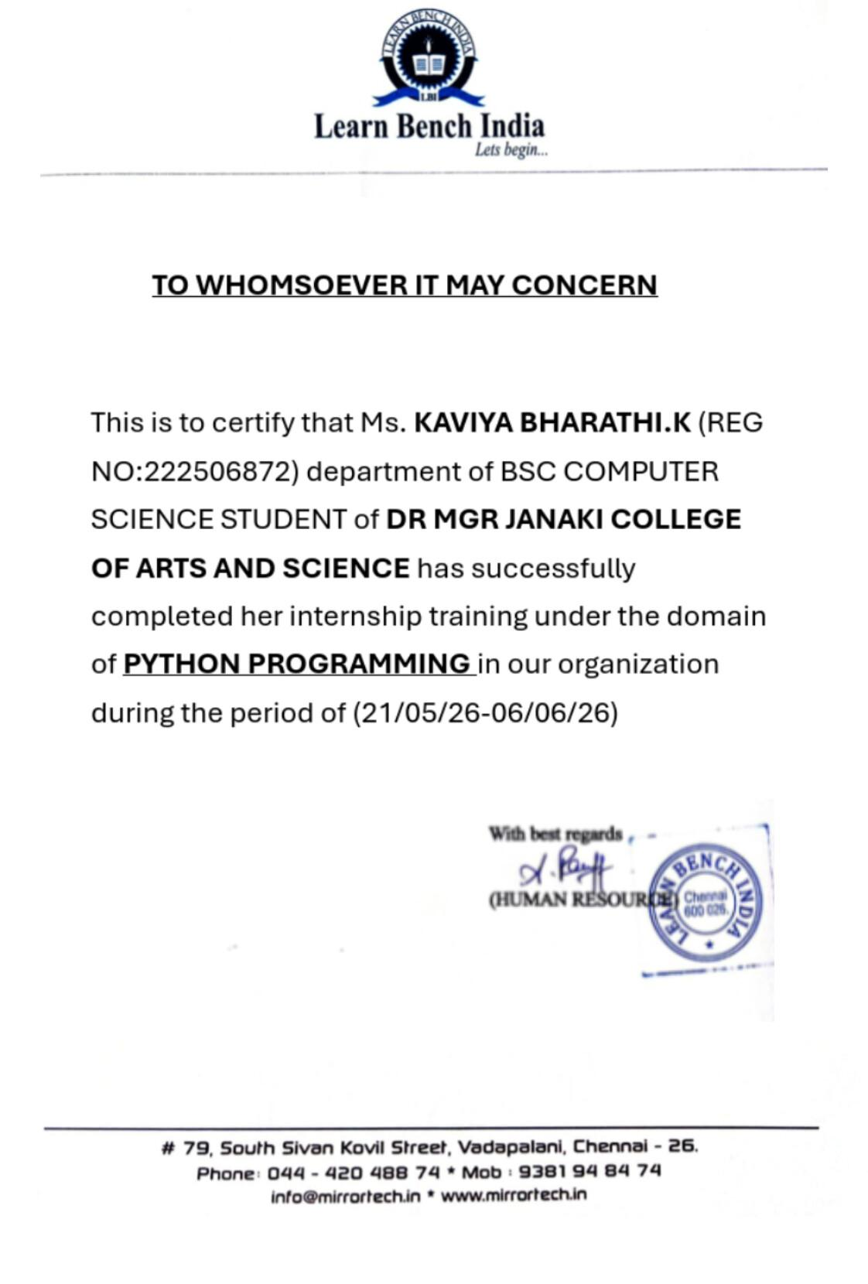

Abstract

Python is a high-level, interpreted, and general-purpose programming language. It is popular because of its simple syntax, readability, and wide range of applications. This study covers the basic concepts of Python programming, including variables, data types, operators, control statements, functions, classes, objects, inheritance, polymorphism, file handling, exception handling, collections, and multithreading. Python is widely used in web development, data science, artificial intelligence, machine learning, automation, game development, and scientific computing. Learning Python helps to improve programming knowledge, logical thinking, problem-solving skills, and coding abilities. Thus, Python is an important and useful programming language for both beginners and professional developers.

S.NO. | CONTENTS | PAGE NO.
1. | Introduction
2. | Feature of python
3. | Variables, Data types and Operators in python
4. | Control statement in Python
5. | Classes and Object in Python
6. | Inheritance in Python
7. | Polymorphism in Python
8. | File handling in python
9. | Expection Handling in python
10. | Python Collections
11. | Applications of python
12. | Multithreading in python
13. | Skill and knowledge Guided in python programming
14. | Conclusion
15. | Reference
TABLE OF CONTENT

Introduction of Python

Python is a high-level programming language. It was created by Guido van Rossum in 1991. Python is easy to learn and use because its syntax is simple and easy to understand.

Python is used for web development, data science, artificial intelligence, machine learning, automation, and software development.

Example:

Print ("Hello World")

Output:

Hello World

1
Features of Python

Easy to Learn – Python has simple and easy-to-understand syntax.

Easy to Read – Python programs are clear and readable.

Free and Open Source – Python is freely available to use and distribute.

High-Level Language – Programmers do not need to manage computer hardware or memory directly.

Interpreted Language – Python executes code line by line.

Object-Oriented – Python supports classes, objects, inheritance, and other OOP concepts.

Portable – Python programs can run on different operating systems such as Windows, Linux, and macOS.

Dynamically Typed – There is no need to declare the data type of a variable.
x = 10
Name = "Python"

Large Standard Library – Python provides many built-in modules and functions.

Extensible and Embeddable – Python can be combined with languages like C and C++.

Supports GUI Programming – Python can be used to create graphical applications.

Used in Many Fields – Python is used in web development, data science, artificial intelligence, machine learning, automation, and software development.
2
Variables, Data Types and Operators in Python
Variables
A variable is a name used to store data in a program.
Example:
name = "Geetha"
age = 20
marks = 85.5
print(name)
print(age)
print(marks)
Output:
Geetha
20
85.5
Data Types
A data type defines the type of data stored in a variable.
Data TypeExample
int
10
float
10.5
str
"Python"
bool
True or False
list
[1, 2, 3]
tuple
(1, 2, 3)
3
dict
{"name": "Geetha"}
Example:
a = 10
b = 10.5
name = "Python"
is_valid = True
print(type(a))
print(type(b))
print(type(name))
print(type(is_valid))
3. Operators
Operators are symbols used to perform operations on values.
a) Arithmetic Operators
a = 10
b = 3
print(a + b) # Addition
print(a - b) # Subtraction
print(a * b) # Multiplication
print(a / b) # Division
print(a % b) # Modulus
print(a ** b) # Power
b) Comparison Operators
a = 10
b = 5
print(a > b)
print(a < b)
print(a == b)
print(a != b)
4
c) Logical Operators
a = 10
b = 5

print(a > 5 and b < 10)
print(a > 15 or b < 10)
print(not(a > 5))
d) Assignment Operators
x = 10
x += 5
print(x) # 15

5
Control Statements in Python
Control statements are used to control the flow of a program.
1. if Statement
It executes the statement when the condition is true.
age = 18
if age >= 18:
print("Eligible")
2. if-else Statement
It checks whether a condition is true or false.
mark = 50
if mark >= 35:
print("Pass")
else:
print("Fail")
3. for Loop
It is used to repeat a statement several times.
for i in range(1, 4):
print(i)
Output:
1
2
3
4. while Loop
It repeats the statement while the condition is true.
i = 1
while i <= 3:
print(i)
i = i +
It is used to stop a loop.
6
5. break
for i in range(1, 5):
if i == 3:
break
print(i)

Classes and Objects in Python
Class
A class is a blueprint or template used to create objects. It contains data and functions.
Object
An object is an instance of a class. It is used to access the data and functions of a class.
Example:
class Student:
name = "Geetha"
age = 20
def display(self):
print(self.name)
print(self.age)
# Creating an object
s1 = Student()
# Calling the function
s1.display()
Output:
Geetha
20

7
Inheritance in Python

Inheritance is an important feature of Object-Oriented Programming (OOP). It allows one class to acquire the properties and methods of another class.
Parent Class / Super Class → The class whose properties are inherited.
Child Class / Sub Class → The class that inherits properties from the parent class.
Types of Inheritance
1. Single Inheritance
2. Multiple Inheritance
3. Multilevel Inheritance
4. Hierarchical Inheritance
5. Hybrid Inheritance

Example:
class Parent:
def display(self):
print("This is the Parent class")

class Child(Parent):
def show(self):
print("This is the Child class")
obj = Child()
obj.display()
obj.show()

Output:
This is the Parent class
This is the Child class

8
Polymorphism in Python
Polymorphism means “one name, many forms.”
It allows the same method or function to perform different actions.
Simple Example:
class Dog:
def sound(self):
print("Bark")
class Cat:
def sound(self):
print("Meow")
d = Dog()
c = Cat()
d.sound()
c.sound()

Output:
Bark
Meow

9
File Handling in Python

File handling is used to create, read, write, and modify files using Python.
File Opening Modes
r – Read
w – Write
a – Append
x – Create a new file

Example: Writing to a File
file = open("example.txt", "w")
file.write("Welcome to Python")
file.close()

Example: Reading a File
file = open("example.txt", "r")
content = file.read()
print(content)
file.close()

Output:
Welcome to Python

10
Exception Handling in Python
Exception handling is used to handle errors that occur during the execution of a program. It prevents the program from stopping suddenly.
Python uses try and except blocks to handle exceptions.

Example:
try:
a = 10
b = 0
print(a / b)
except:
print("Cannot divide by zero")
Output:
Cannot divide by zero
Example 2: Handling Invalid Input
try:
number = int("Hello")
print(number)
except:
print("Invalid input")
Output:
Invalid input

11
Python Collections

Collections are used to store multiple values in a single variable. Python has four main collection data types:
1. List
A list is ordered and changeable.
fruits = ["Apple", "Banana", "Mango"]
print(fruits)
Output:
['Apple', 'Banana', 'Mango']
2. Tuple
A tuple is ordered but cannot be changed.
numbers = (10, 20, 30)
print(numbers)
3. Set
A set is unordered and does not allow duplicate values.
numbers = {1, 2, 3, 3}
print(numbers)
Output:
{1, 2, 3}
4. Dictionary
A dictionary stores data in key-value pairs.
student = {
"name": "Geetha",
"age": 20
}
print(student["name"])
Output:
Geetha

12
Applications of Python
Python is a powerful programming language used in many fields.
1. Web Development
Python is used to create websites and web applications.
Example: Django and Flask are Python frameworks.
print("Welcome to my website")
2. Data Science
Python is used to analyse and understand data.
Example: Calculating the average of marks.
marks = [80, 90, 70]
print(sum(marks) / len(marks))
3. Artificial Intelligence and Machine Learning
Python is used to create intelligent systems and machine learning models.
Example: A system that predicts house prices or recognizes images.
4. Automation
Python can automatically perform repeated tasks.
Example:
for i in range(3):
print("Task completed")
5. Game Development
Python is used to develop simple games.
Example: The Pygame library is used for game development.
6. Desktop Applications
Python can be used to create desktop applications
Example: Calculator application using Tkinter.
print("Calculator Application").

13
7. Scientific and Mathematical Computing
Python is used for mathematical calculations and scientific research.
import math
print(math.sqrt(25))
Output:
5.0

14
Multithreading in Python
Multithreading is a technique that allows a program to run multiple tasks at the same time. A thread is a small unit of execution within a program.
It is useful for performing multiple tasks efficiently, such as downloading files or handling multiple activities.
Example:
import threading
def task1():
print("Task 1 is running")
def task2():
print("Task 2 is running")
t1 = threading.Thread(target=task1)
t2 = threading.Thread(target=task2)
t1.start()
t2.start()
t1.join()
t2.join()
Output:
Task 1 is running
Task 2 is running
Explanation:
import threading imports the threading module.
task1() and task2() are two different tasks.
Thread() creates a new thread.
start() starts the threads.
join() waits for the threads to finish.

15
Skills and Knowledge Gained
- Learned the basic concepts of Python programming.
- Understood variables and different data types.
- Learned to use arithmetic, comparison, and logical operators.
- Gained knowledge of conditional statements such as if, else, and elif.
- Learned how to use for and while loops.
- Understood the concept of functions and code reusability.
- Learned about classes and objects in Python.
- Understood inheritance and polymorphism in OOP.
- Learned to handle files using file handling.
- Learned how to manage errors using exception handling.
- Gained knowledge of Python collections like List, Tuple, Set, and Dictionary.
- Improved logical thinking and problem-solving skills.
- Developed the ability to write simple Python programs.
- Gained basic knowledge of Object-Oriented Programming.
- Improved debugging and error-handling skills.
- Learned how to write simple, readable, and reusable code.
- Gained confidence in developing basic Python applications.

16
Conclusion

Python is one of the most popular and powerful programming languages in the world. It has a simple syntax and is easy for beginners to learn. In Python programming, we learned important concepts such as variables, data types, operators, control statements, functions, classes, objects, inheritance, polymorphism, file handling, exception handling, and collections.

Python also supports object-oriented programming and provides many built-in functions and libraries. It is widely used in web development, data science, artificial intelligence, machine learning, automation, and software development.

Learning Python helps to improve logical thinking, problem-solving skills, coding skills, and programming knowledge. Therefore, Python is an excellent language for beginners as well as professional programmers

17
REFERENCE:
1. Python Official Documentation – https://www.python.org/doc/
2. Programmes Python Guide – https://www.programiz.com/python-programming
3. Python for Data Science – Kaggle Learn – https://www.kaggle.com/learn/python

18

